Pridham, Frank
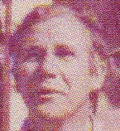
Forester training in UK. Fought in World War II. Forester in Tanzania from 1952. Awarded MBE for services to forestry in Tanzania. Joined Forest Department of W.A. in 1964 at Dwellingup. Transferred from Dwellingup to Manjimup 4.1.1968. Transferred from Manjimup to Nannup in 1971. In Fire Protection Branch in Northern Region, until taking up training duties in 1972, including OIC of cadets. Training officer for many years. Retired 1987.

